Microsoft Presidio Setup & Usage Guide
1. Introduction
Microsoft Presidio is an open-source framework used for detecting and protecting Personally Identifiable Information (PII) in both structured and unstructured data.
It provides:
- PII detection (Analyzer)
- Data protection (Anonymizer)
- Flexible integration (Python)
2. Prerequisites
Before installing Presidio, ensure:
- Python (3.8 or above)
- pip installed
- Internet connection
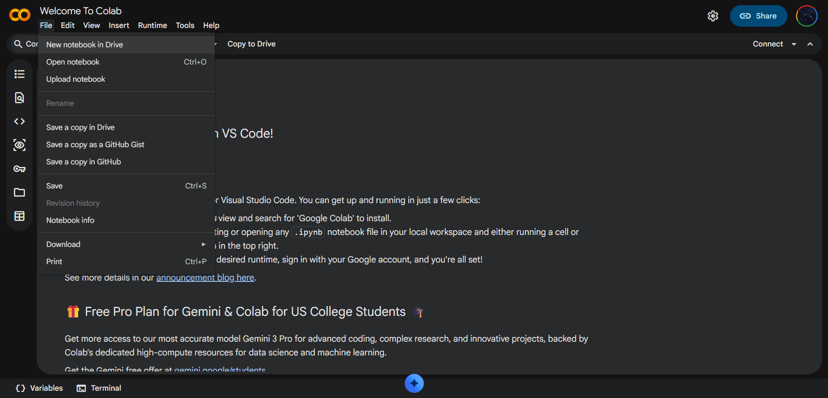
Step 1: Open Google Colab
- Go to https://colab.research.google.com
- Click New Notebook

Step 2: Install Libraries
Run this in the first cell:
!pip install presidio-analyzer presidio-anonymizer pandas
!python -m spacy download en_core_web_lg
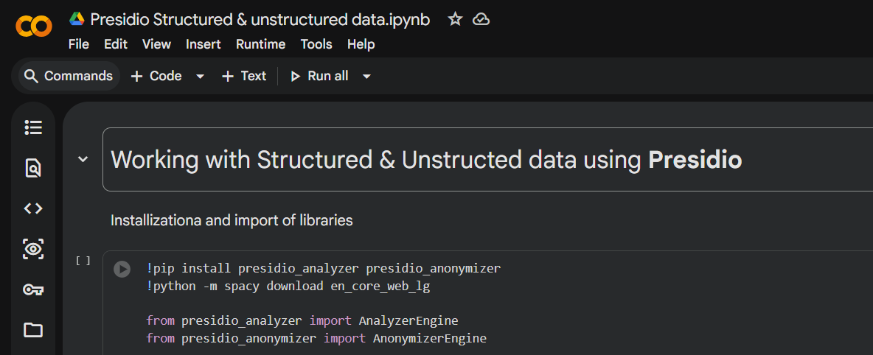
Step 3: Upload Files
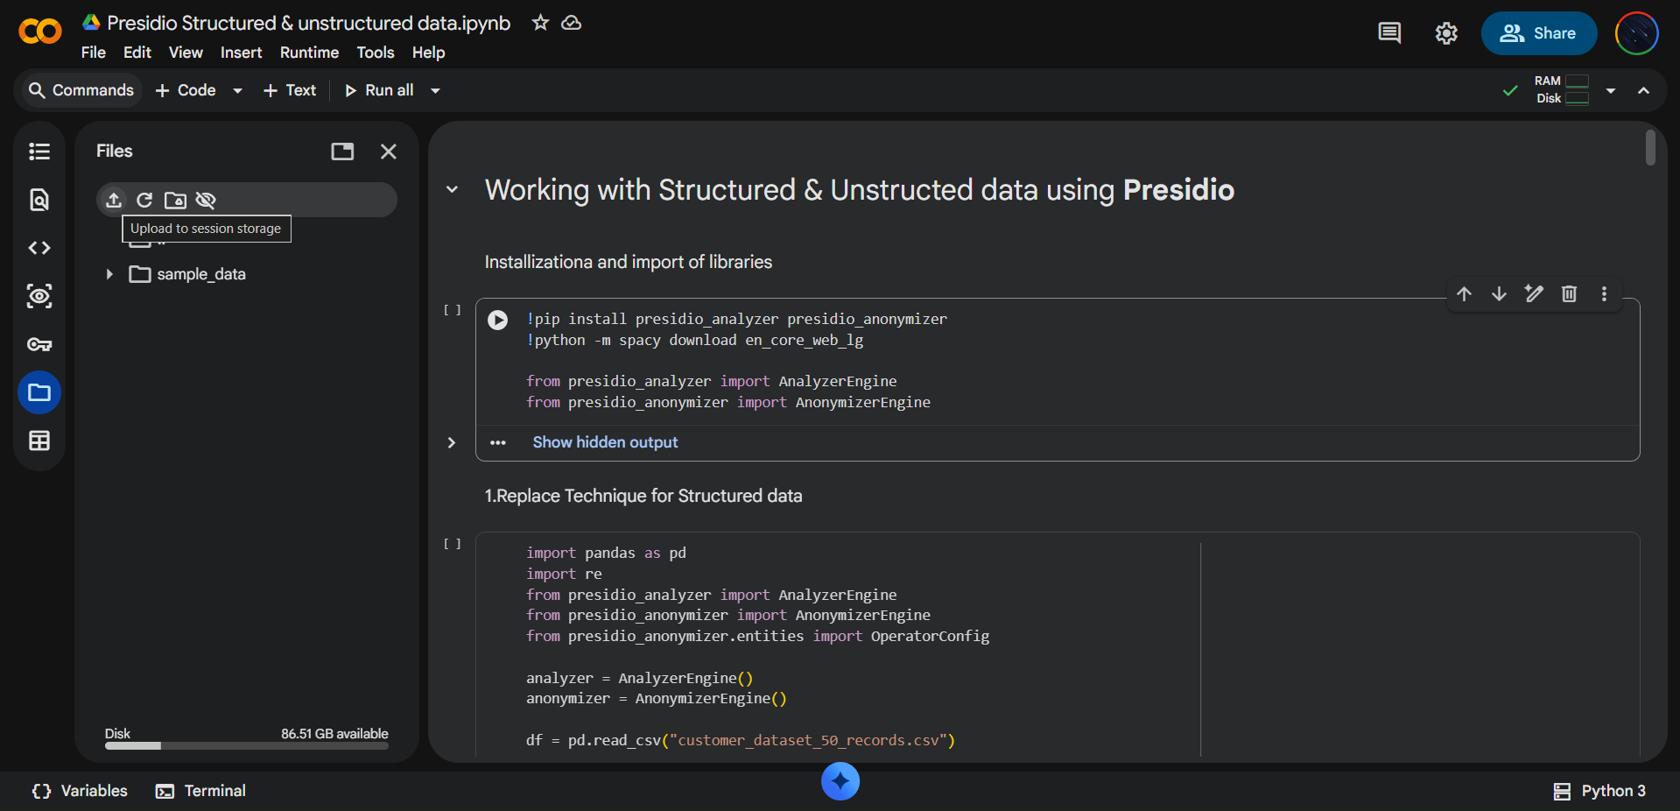
Run:
from google.colab import files
uploaded = files.upload()

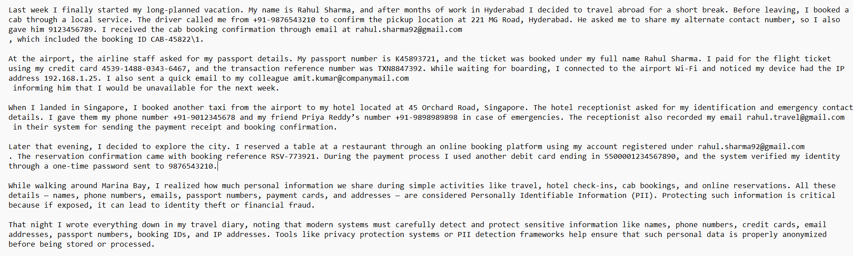
Upload:
- Vacation Diary Entry.txt (unstructured)
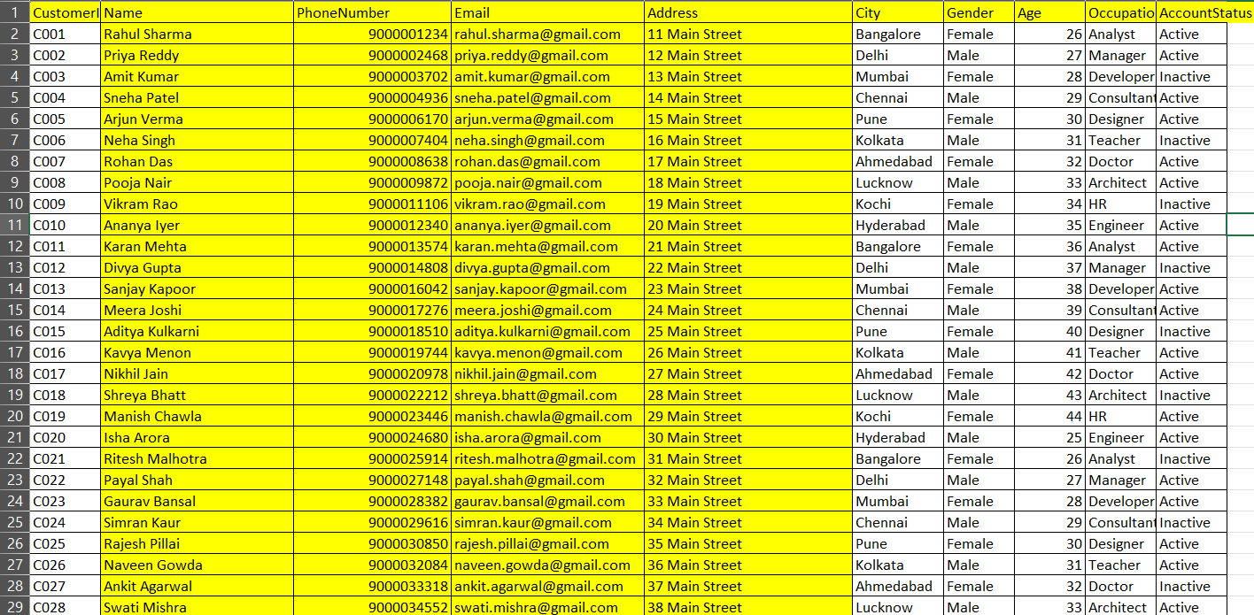
- customer_dataset_50_records.csv (structured)

i)Unstructured Data Masking (Text File)
from presidio_analyzer import AnalyzerEngine
from presidio_anonymizer import AnonymizerEngine
from presidio_anonymizer.entities import OperatorConfig
analyzer = AnalyzerEngine()
anonymizer = AnonymizerEngine()
with open("Vacation Diary Entry.txt", "r", encoding="utf-8") as file:
text = file.read()
results = analyzer.analyze(text=text, language="en")
operators = {
"DEFAULT": OperatorConfig(
"mask",
{"masking_char": "*", "chars_to_mask": 100, "from_end": False}
)
}
anonymized_result = anonymizer.anonymize(
text=text,
analyzer_results=results,
operators=operators
)
with open("mask.txt", "w", encoding="utf-8") as file:
file.write(anonymized_result.text)
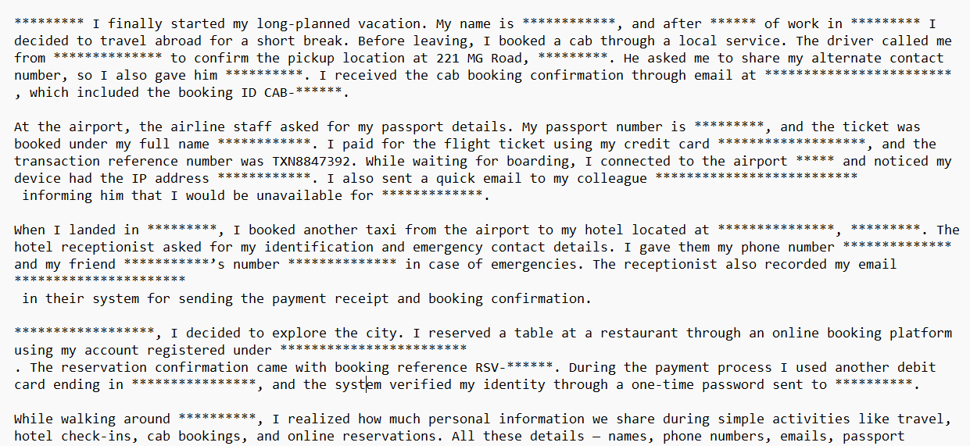
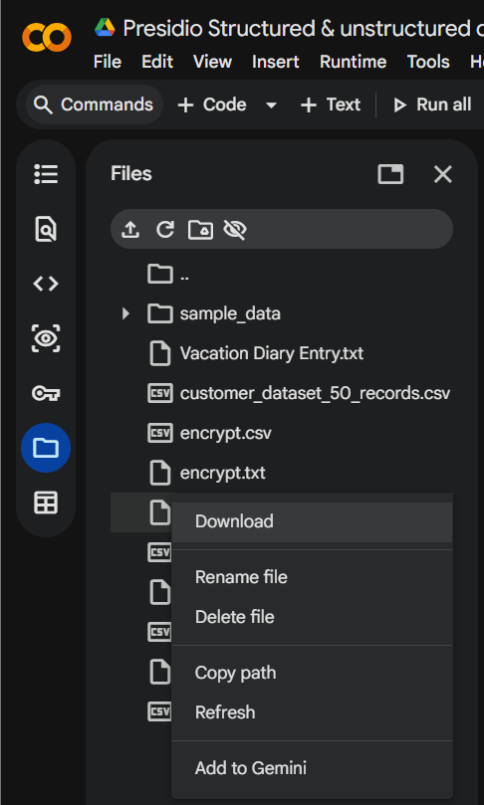
Download Output as shown & you can see the output:
ii)Structured Data Masking (CSV)
from presidio_analyzer import AnalyzerEngine
from presidio_anonymizer import AnonymizerEngine
from presidio_anonymizer.entities import OperatorConfig
# Initialize
analyzer = AnalyzerEngine()
anonymizer = AnonymizerEngine()
df = pd.read_csv("customer_dataset_50_records.csv")
pii_columns = ["Name", "PhoneNumber", "Email"]
# Presidio mask operator
operators = {
"DEFAULT": OperatorConfig(
"mask",
{
"masking_char": "*",
"chars_to_mask": 100,
"from_end": False
}
)
}
# Function for Presidio masking
def mask_pii(text):

if pd.isna(text):
return text
results = analyzer.analyze(
text=str(text),
language="en",
entities=["PERSON", "PHONE_NUMBER", "EMAIL_ADDRESS"]
)
anonymized = anonymizer.anonymize(
text=str(text),
analyzer_results=results,
operators=operators
)
return anonymized.text
# Apply Presidio masking (only safe columns)
for col in pii_columns:
df[col] = df[col].apply(mask_pii)
def mask_full(value):
if pd.isna(value):
return value
return "*" * len(str(value))
df["Address"] = df["Address"].apply(mask_full)
# Save output
df.to_csv("final_mask_output.csv", index=False)
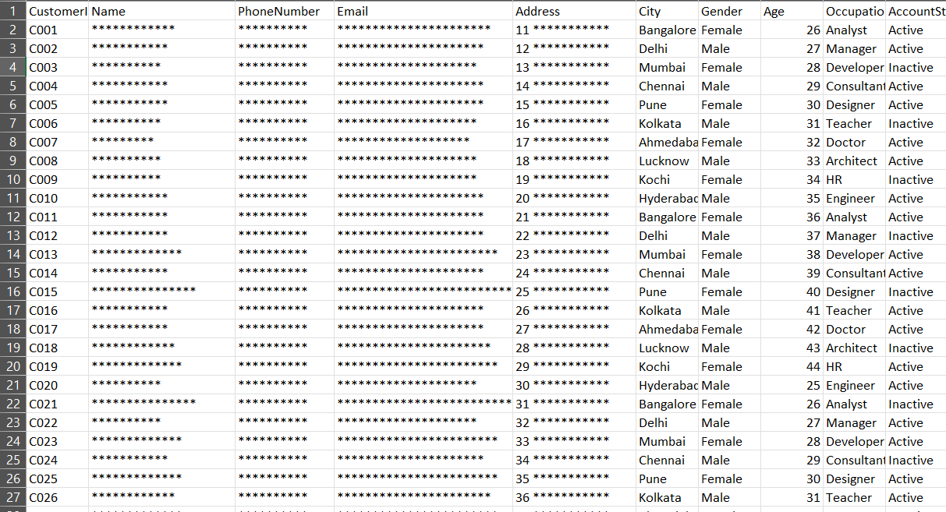
>Download the output as shown & you can see the output

Conclusion:
This process allows masking of sensitive data in both structured and unstructured formats using Microsoft Presidio.
Or else Click here: Working with Presidio for structured and unstructured data
& upload the both
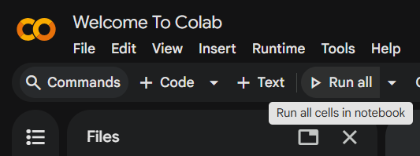
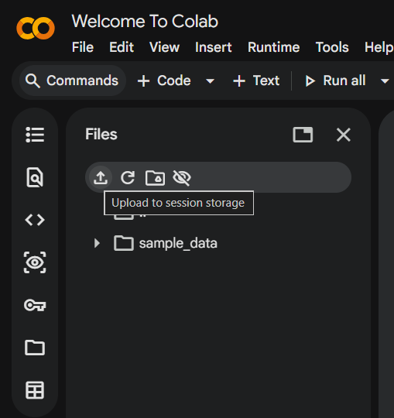
structured and unstructured input files and Run the code

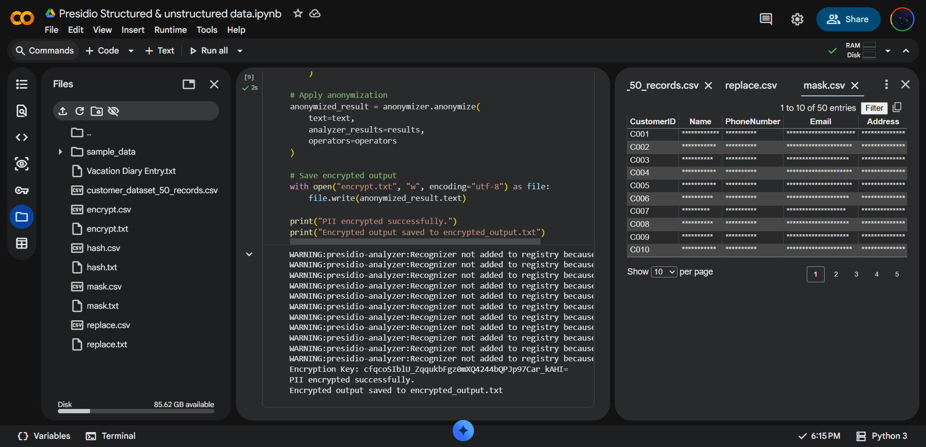
ou can view the direct output in like this:

